FBI
Range Construction
&
Services for Simunition House Contract

Statement of Work (SOW)

23 February 2021

Project Title: Federal Bureau of Investigation (FBI) Simunition House
For: Field Office of the FBI, New Orleans, Louisiana

Background: In 1934 Congress gave Federal Bureau of Investigation (FBI) agents the authority to carry firearms. In response, the FBI began a robust firearms training program, which has continuously grown and evolved through the years in order to keep pace with technology and best prepare agents and FBI police officers for the increasing dangers and threats they face while carrying out their assignments, domestically and internationally. Their mission is to develop and deliver a comprehensive and consistent firearms training curriculum that provides new agent trainees, special agents, and police officers the skills needed to use firearms safely and effectively, if necessary, while performing their duties. Experienced firearms training instructors also offer certification and recertification training to all FBI firearms instructors who provide training to agents in the field and in support of our state and local law enforcement partners.

Problem Statement: The Federal Bureau of Investigation (FBI) does not have sufficient training facilities for the FBI and local law enforcement agencies within the New Orleans, LA area.

Scope: This Statement of Work (SOW) requires the procurement of professional services to Design and Build a PEMB Simunition (SIM) House at the Camp Villere National Guard Training Center, Slidell, LA.

2.1 Description of Services Required: This Statement of Work shall serve as the basis for a detailed cost proposal and subsequent negotiation between the Government and the Design Build Contractor, hereafter known as the contractor, to provide all necessary professional and technical services and support to fully satisfy the Government’s requirements identified herein to perform the tasks identified below. The contractor shall provide all management supervision, labor, materials, supplies and equipment and shall investigate, plan, schedule, coordinate and assure effective performance of all services required. The contractor shall subcontract the services of qualified sub-consultants as needed to complete the work required. The Government reserves the right to approve or deny any proposed sub-consultants.

2.2. Proposal for Services Required: With this Statement of Work, the Government seeks the services of a contractor to produce 100% construction documents, signed and sealed by licensed design professional then complete the scope of work required to provide a complete project. The proposal shall describe the contractor’s design and construction intent for how they propose to perform the services to complete the work required.

2.3 Project Schedule: Period of performance for this project shall be no more than 240 calendar days or less from Notice to Proceed (NTP).

The contractor’s proposal shall include a schedule for performance of the required services in simple bar chart form, identifying milestone dates for each major element of design and construction administration, including inspection period, report and design review submissions, cost estimate submissions, etc. The schedule shall also identify a critical path for the project’s completion to include survey, design phases, design submissions and Government review periods, construction and close out. The Government review periods will generally be 14 calendar days.

The purpose of the project schedule is to ensure adequate planning, coordination, scheduling, and reporting during execution of design and construction activities of the contractor. The project schedule will assist the contractor and the Contracting Officer in monitoring the progress of the work, evaluating proposed changes, and processing the contractor's monthly progress payment requests.
The work in this SOW shall be completed in accordance with the following schedule:

1.Over the Shoulder Government Review:
a. Work on 50% Draft DB Construction Documents shall begin upon the NTP and shall address the design requirements as identified in the RFP package for the project as established by the FBI.
b. Refer to 4.0 Technical Documents Submissions and Deliverables of this SOW.

2. 50% Design Development Construction Documents:
a. Work on the 50% Draft DB Construction Documents shall continue to be developed.
b. Refer to 2.3 Technical Documents Submissions and Deliverables of this SOW.

3. 100% Construction Documents:
a. Work on Construction Documents shall continue during the Design Development Documents review and once Design Development Government review comments are received, they shall be addressed and incorporated in the Construction Documents.
b. Refer to 4.0 Technical Documents Submissions and Deliverables of this SOW.

4.Proof Submission:
a. Incorporate the Government design review comments from the 100% construction document review.
b. QC all drawings and specification and adjust accordingly.
c. Refer to 4.0 Technical Documents Submissions and Deliverables of this SOW.

5.Complete Stamped and Sealed IFC Final Submission:
a. Written responses to the Government’s 100% Construction Document review comments submitted no later than 30 calendar days after receipt of Government’s100% Construction Document review comments.
b. Complete stamped and sealed IFC final submission prior to construction.

6. Construction:
a. Construction completed within the identified period of performance.

7. As-Constructed Drawings:
a. As-Constructed (As–Builds) Drawings completed no later than 30 calendar days after Project Completion.

8. All Schematic Design, Design Development, Construction Documents and As-Constructed Drawings shall be submitted to the Government’s representative for the project.

2.4 Technical Requirements and Deliverables

2.4.1. General Design Requirements for the Scope of Work

1. The Scope of Work’s primary purpose is to develop a construction document set that addresses the development of construction documents and construction of the PEMP project.
2. The contractor shall provide all management supervision, labor, materials, supplies, and equipment(except as otherwise provided by the Government or others as described herein) and plan, schedule, coordinate, and assure effective quality performance of all services required herein.
3. The contractor shall provide a fee/cost breakdown of both the professional design services and construction services as part of the project.
4. Project quality shall be an integral part of the project, so a QA/QC Program shall be established by the contractor and be in place and active from project inception through completion. This will enable the contractor to maintain the standards of excellence, efficiency, reliability, and safety that the FBI and specifically this project deserves.
5. The contractor is responsible for making sure all workers use proper personal protective equipment that meet OSHA requirements as required while on site.
6. The contractor shall have weekly status update meetings via teleconference or on site with the Government to address the project progress and any concerns or potential delays and monthly meetings on site.
7. Each project submission should be submitted with track changes to indicate all changes made to the documents from the last submission. At the end of the project the final deliverable shall have all changes accepted.
8. With each submission, the contractor shall prepare a report to include, but not be limited to, the following: Basis of design, problems encountered, recommended actions, potential problems, outstanding issues to be resolved, schedule, response to previous submission comments, and a detailed cost estimate.
9. Following each review submission, the Government will perform a technical and constructability review of the documents. At the conclusion of each review, the contractor will receive written comments generated by the Government review team. The contractor must respond to each comment in writing back to the review team within 14 calendar days.
10. All written documents shall be submitted as a Microsoft Word file type.
11. Kick-off Meeting: Key contractor personnel, the CO, the COR and PM shall meet at the FBI New Orleans Field office or teleconference within five (5) calendar days after Contract award to discuss the project’s scope of work, project processes, procedures and schedules will be confirmed as well as the project organizational chart, paths of communication, means of communication, responsibilities, quality assurance/quality control and access control/security management. The Government and the contractor will also visit the site to identify and discuss any potential concerns or issues.
12. After the completion of construction, the contractor shall revise and update the construction document files as a CD disk to incorporate the construction contractor’s “Record Drawings.” The electronic version of the documents shall be submitted to the FBI as a fully functional set of drawings and specifications and the Government will have full use of all documents and work developed in the performance of this project.
13. The contractor expressly agrees not to publish, disclose or disseminate in any form the findings, recommendations, work products, or information relating to the work set forth herein without prior written approval from the Government.
14. The contractor shall be responsible for assuring all design work, drawings, specifications and other design documents have been fully coordinated and meet all the requirements of the contract. Quality Control and Quality Assurance of all design services and work product is the contractor’s responsibility.
15. The contractor shall remain responsible for the accuracy and correctness of all architectural and engineering concepts, cost estimates, and details of work including the coordination of various architectural, engineering and other disciplines with each other.
16. All work must be in accordance with applicable criteria, guides, national and local codes and shall be in accordance with the best architectural and engineering practices. Workmanship shall be neat with all lines and lettering of uniform weight and clarify for complete legibility and satisfactory reproduction.
17. The contractor shall provide his/her own meals, lodging, and transportation to and from the project site and while on-site. Although travel is not anticipated, any travel that arises under this contract shall be in accordance with the Federal Travel Regulations.
18. Design/Construction Packages: The Government will entertain this project being organized (design & constructed) based on pre-determined packages: Utilities, Site/Civil, Core/Shell, etc. With this approach, the Government would be looking for the project to be expedited.

2.4.2 Document Security

1. All documents used and created for this project are Sensitive but Unclassified (SBU).
2. For the purposes of this contract, the contractor shall safeguard SBU information in strict accordance with FBI guidelines and if not provided the requirements set forth within the latest edition of the General Services Administration’s Public Building Service (PBS) ORDER 3490.
3. SBU information may not be transmitted over the internet or any other network that would allowing individuals without the proper clearances and not associated with the project to directly or indirectly have access to it. SBU information is considered secure for transmittal over the internet only if properly encrypted according to Advanced Encryption Standard (AES) 256.
4. The contractor shall ensure that the construction documents are secured on-site at all times and that the construction documents are seen and reviewed only by those personnel with the proper security clearances and need to know.
5. All documents shall be marked on the cover page with the following disclaimer:

PROPERTY OF THE UNITED STATES GOVERNMENT
COPYING, DISSEMINATION, OR DISTRUBITION OF THESE DRAWINGS,
PLANS, OR SPECIFICATIONS TO UNAUTHORIZED USERS IS PROHIBITED.
Do not remove this notice.
Properly destroy or return documents when no longer needed.

6. All documents shall be marked on all pages subsequent to the cover page as follows:

PROPERTY OF THE UNITED STATES GOVERNMENT
FOR OFFICIAL USE ONLY
Do not remove this notice
Properly destroy documents when no longer needed

7. The contractor its staff/sub-contractors shall be required to sign a Sensitive but Unclassified (SBU) non-disclosure agreement and shall maintain document control during the project with all documents distributed numbered and logged. All documents shall be returned to the contractor at the completion of the project and properly destroyed or returned to the FBI New Orleans Field Office.

2.4.3. Construction and Administration Requirements
1. The contractor shall advise and consult with the FBI during the construction phase. Instructions, clarifications, or other information shall be copied to the FBI’s Contracting Officer (CO) and the FBI’s on-site Contracting Officer’s Representative (OSCOR), .
2. The contractor shall be available during project working hours for telephone conversations with the FBI CO/COR/OSCOR to resolve construction problems and to clarify details of the construction documents.
3. The contractor shall review all submittals, samples, and shop drawings for accuracy, completeness, conformance to the contract documents, coordinating them for conformance with the design intent. All reviews shall be completed within 14 calendar days of receipt.
4. The contractor’s QCM shall review all submittals prior to sending to CO/COR/OSCOR for acceptance. The submittal(s) shall be stamped/acknowledged by the contractor for compliance to the contract documents.
5. The contractor shall set up and maintain logs which track the receipt, processing and return of submittals, shop drawings, Notice of Deficiencies (NOD’s), and Requests for Information (RFI’s).
6. As required, the Government shall prepare clarification notices or other notification/direction necessary to respond to an RFI or similar issue raised during the progress of construction.
7. The contractor shall provide written responses, analysis, or recommendations in resolution of construction issues associated with RFI’s and respond to them within 3 working days. An item on an RFI which is on the critical path shall be responded to as dictated by the potential impact on the schedule and be copied to the OSCOR representative.
8. The contractor shall walk and review the construction site a minimum of 2 times per month and prepare site reports for the FBI CO/COR/OSCOR and submitted within 48 hours of each visit. These written site reports shall identify any unusual conditions, general observations, workmanship, deficiencies, and construction problems, including problems associated with the contract documents. The contractor shall perform a monthly review of the contractor’s daily reports and as-built drawings and report any discrepancies to the CO/COR/OSCOR. The contractor’s reports shall itemize or specifically identify all actions required, or that are being taken to expedite a resolution of a construction issue, such as supplemental instructions, Request for proposals or Rejection of Work.
9. The contractor shall inspect the site monthly in order to review job progress and verify the contractor’s percentage of completion for job progress payment purposes.
10. The contractor shall review all proposals submitted for any cost and schedule impact changes to the project.
11. The contractor shall attend a minimum of bi-weekly progress meetings or any other special meetings that are required at the job site regarding job progress.
12. The contractor with the Government’s Representatives shall conduct inspections and prepare punch lists to determine the date of substantial completion and final completion. The contractor shall receive, review, and forward to the FBI CO/COR/OSCOR written warranties and related documents required by the construction documents issue a final Certificate for Payment.
13. The extent of the duties, responsibilities, and limitations or authority of the contractor to support the Government’s representative during construction shall not be modified or extended without written consent of the FBI CO.
14. Any utility shutdowns that affect any occupied buildings or are required for the work shall be coordinated through the FBI CO/COR/CMU/PDU. The contractor shall provide the FBI OSCOR with a minimum of 14 days’ notice for all utility shutdowns.
15. The contractors workday shall be within the hours of 6:00 am and 6:00 pm but flexibility within the normal work day as to hours worked shall be coordinated with the Contracting Officer’s Representative, or COR. Week End, night and holidays work will have to be arranged 2 weeks in advance and be approved by the Government CO.
16. The contractor shall, without additional expense to the Government, be responsible for obtaining any necessary licenses, fees, inspections, and permits, and for complying with any federal, and municipal laws, codes, and regulations applicable to the performance of the Work.

17. The contractor shall be responsible for all damages to persons or property that occur as a result of the contractor’s fault or negligence and take proper safety and health precautions to protect the work, workers, public, and property of others.
18. The contractor shall be responsible for all materials delivered and work performed until completion and acceptance of the entire work, except for any completed unit of work which may have been accepted under this contract.
19. The contractor will coordinate start date and on-site storage areas with the Government representatives.
20. The contractor is responsible for leaving the site free from debris and shall clean up and remove all debris, excess material and equipment from the site at the end of the work prior to submission for final payment.

2.5. Project Meetings

2.5.1. Design Meeting

After the award of the contract and acceptance of the Performance and Payment bonds, the CO will arrange a design meeting with the contractor. The meeting agenda shall include the following as a minimum:

- Review and emphasize the Government’s needs and design objectives.
- Schedule (Critical Path Method Scheduling).
- Design schedule (provide minimum of two color hard copies & electric copy). Note: No portion of the work can begin construction until 100% Complete Design Build Construction Documents are approved for that portion and any other portion of the work that may be affected by it.
- Modifications during design

2.5.2. Preconstruction Meeting

The following Project Requirement deliverables shall be submitted at a minimum 2 weeks after contract NTP:
- Letter designating the Project Superintendents, Safety and Quality Control persons.
- Project Schedule with the design and construction portion fully developed.
- Safety Program
- A list of subcontractors for this project and point of contacts
- Quality Control Plan
- Shop Drawing Submittal Log.
After 100% Complete Design Build Construction Documents are approved (or completed portions of documents necessary for fast tracking the project), and prior to the start of construction, the CO will arrange an on-site Preconstruction meeting with the contractor. The meeting agenda will include the following as a minimum:

- Correspondence procedures
- Roles and responsibilities
- Lines of Authority
- Mobilization activities / Logistic Plan
- RFI’s
- Security Procedures
- Utility Interruptions
- Progress Payments
- Submittal process
- Construction schedule (provide a minimum of two color hard copies and electronic copy in software it was created in) Note: No portion of the work can begin construction until 100% Complete Design Build Construction Documents are approved for that portion and any other portion of the work that may be affected by it.
- Modifications
- Accident reporting
- Medical emergency processes, availability, emergency numbers, and contacts.
- FBI Rules and Regulations

2.5.3. Progress Meetings
The contractor shall participate in weekly telephone conference calls / site meetings with the Contracting Officer, and other project team members to update everyone on the following meeting agenda items:

- Approval of minutes of previous meetings
- Submittal status
- Review of off-site fabrication and delivery
- Requests for Information (RFI’s) and issues
- Modifications
- Work in progress and projected 3-week look ahead.
- Schedule update (provide updated CPM schedule)
- Status of Project Record Drawings and O&M Manuals
- Upcoming utility outages
- Other business relating to work

2.6. Environmental and Safety Concerns
The Government is not aware of environmental issues related to the site.

Applicable Documents/References:

Codes & Regulations
In the development of the construction documents for the Project, the contractor shall follow the latest editions of the national model building and other codes and standards stipulated below. The contractor is responsible for determining the additional codes and regulations appropriate for this project and shall in no way be relieved of such responsibility. The contractor shall not interpret this list as being complete for all applicable codes, regulations and standards groups.

If elements of the Codes or Standards listed below conflict with written direction from the local AHJ, those elements will not be enforced by the government. Where more than one Code or Standard applies, and they do not conflict, the most stringent will be enforced by the government. Any existing space/building new construction used as part of this procurement shall be brought up to current code standards to the greatest extent feasible.

1. International Building Code (IBC),
2. International Fire Code (IFC),
3. American Concrete Institute (ACI) 301,
4. National Electric Code,
5. National Fire Protection Association (NFPA) Codes
6. NFPA Fire Protection Handbook,
7. NFPA 101/ Life Safety Code,
8. Underwriter’s Laboratories (UL) Building Materials Directory
9. Underwriter’s Laboratories (UL) Fire Resistance Directory
10. Louisiana Uniform Statewide Building Code.
11. National Fire Protection Association (NFPA) 70 National Electrical Code.
12. National Fire Protection Association (NFPA) 72 National Fire Alarm Code.
13. National Fire Protection Association (NFPA) 780 Standard for installation of Lightning.
14. Occupational Safety and Health Administration (OSHA) Requirements, Standards and Criteria.
15. Electrical Construction Materials Directory.
16. American Institute of Steel Construction (AISC) Manual of Steel Construction.

Tasks:

Task 1: Kick-Off and Preconstruction Site Visit:

Determine specific requirements for project site access by the Contractor.

Determine existing environmental and soil conditions, obtain “as-built” documents, and take photographs/surveys, as required.

Determine distance and accessibility of utilities.

Obtain Government provided Record of Environmental Consideration (REC) if not provided prior to final proposal process, to determine testing and permitting requirements. A modification may be required if the REC requires more than best management practices (BMP) for erosion control if not provided to contractor prior to final proposal submission and attached to this document as an appendix item.

Identify stakeholders for the project and establish the communication matrix between the Contractor and the Customer.

If any major discrepancies are determined, documentation shall be provided and discussed with all required stakeholders no later than seven (7) days from Preconstruction Site Visit.

Design: The Contractor shall design a SIM House. All dimensions referenced in this document are for planning purposes and are to be considered “Approximate”.

Exterior dimensions shall be designed to 50’ wide X 100’ long X 20’ to eaves. The building will be all white in color to assist in keeping the building cool. Several options are listed in the appendix section for bidding purposes.

Foundation and slab shall be engineered to meet project location requirements, to include small vehicular traffic, and shall be stamped by a structural engineer. Bottom level finished floor shall be cured, finished concrete. Sealing or staining is not required. The slab must be able to support the weight of a standard pickup truck.

PEMB shall have gable roof with standing seam roof panels, metal gutters, downspouts, and concrete splash blocks. PEMB will include a fan system which will allow for air flow to enter and exit the building to rapidly remove smoke from diversionary devices and lower the ambient temperature for cooling purposes. The fan system will be designed to prevent rodents and birds from occupying the building. Vents for the system must be removable or replaceable to allow for periodic cleaning.

Reserved

Reserved

The SIM house will include three staircases, one outside and two inside. One inside will be a straight stair way, the other will be a two-level stair way. A ladder should be provided for access to the roof and a flat area for a precision marksman team large enough to allow 2 (two) shooters oriented towards the range targets. Exact measurements to be approved by New Orleans PFI. All materials should be metal. An additional deck and overhead coverage with safety harness shall be priced as an option. The door access to the roof shall prevent water intrusion to the PEMB and needs to lock in the open position to allow for personnel to access/enter the roof to prevent the door from striking the operator. Each landing dimension shall be 4’ X 6’, with grated flooring. The landing shall be supported by four (4) metal columns with base plates welded to one side to anchor to the floor. Columns shall be 4” X 4” structural tube steel. Base plates shall be 10” X 10” X ¾” thick with six (6) each ¾” holes pre-drilled through the base plate. Steel shall be primed and painted, color TBD during design.

As a separate pricing option, moveable walls will be included in the contract in order to make adjustments for room configurations. Walls will be made to comply with local fire codes. If fire codes allow, moveable walls and fixed walls will be constructed out of 2x4 and painted plywood. No more than 10 of these walls will be affixed to wheels and hinges to allow for allow for various room configurations. No more than 10 walls can be designed to accommodate barn sliding doors to open various room configurations to allow for maximum adjustability. When the walls are set for the various configurations, they will be required to be pinned to the floor to assist in the overall stability of the moveable walls. No more than 4,000 square feet will comprise of the moveable wall section within the PEMB. See attached photos.

Reserved.

Construction of a mezzanine shall be a minimum of 20’X20’ to allow for training simulations involving a second floor. Interior stairways and external stairway will access the mezzanine.

Interior walls shall have plywood installed, ¾” in thickness, to 8’ above finish floor. Plywood shall cover interior walls of entire structure and be painted white. Procurement and installation of the plywood shall be priced as an option.

PEMB hall have five (5) each exterior 3070 doorways installed. Four (4) of these doors shall be designed for breach training.

PEMB shall have one (1) each 10’ X 10’ coil-up door, manual operation, with four (4) each 4” steel painted bollards, installed in and filled with concrete, located on the interior and exterior for vehicle protection.

Coil-up door shall have a 12’ by 6’ concrete apron engineered for small vehicular traffic. Apron shall minimally slope away from the building to promote drainage and shall be able to receive and support palletized deliveries that can weigh up to 5,000 pounds each.

Coil up door shall also have a minimum 36” awning and exterior mounted light.

Training Room shall have six (8) each windows, 36” X 44”, double hung style, with screens. The windows shall have a hinged or slider plywood hatch on the inside of the building to allow for darkening the interior of the building.

All exterior 3070 doors shall have a concrete landing, 4’ X 5’, an awning and an exterior mounted light.

Exterior 6070 door shall have a concrete landing, 8’ X 5’, awning and exterior mounted light.

PEMB shall have 4’ wide aggregate apron installed around the perimeter of the PEMB.

Four (4) Breaching Door Styles (See Attachment X – Door Design Drawings)

One (1) Shotgun Lock Door

One (1) Shotgun Hinge Door

One (1) Pry/Ram Door

One (1) Ram/Burglar Bar Door

Fire suppression equipment shall be installed to comply with local and state regulations for size and type of building, ie: mounted portable extinguishers.

Electric shall be 120/240V, 3-phase, 3-wire secondary. Rigid conduit shall be extended 5’ outside the PEMB to receive the underground secondary line. Secondary line shall be installed underground from the PEMB to the power source in conduit.

Electric trench shall be bedded to meet local codes and installed to the existing power supply. The approximate length of the underground secondary required not to exceed 200’. Underground detectable warning tape shall be installed 12” below finish grade. Trench shall be seeded in green space areas and aggregate replaced in roads or parking areas. No road crossings through pavement or concrete or directional boring required.

Provide and install three (3) red-lighted exit signs; one (1) above design dedicated 3070 exit doors.

Provide and install three (3) emergency lights; one (1) above design dedicated 3070 exit doors. Emergency lighting shall be connected to the electric system to charge internal batteries.

Dimmable LED lights with switches shall be designed and installed through-out PEMB. Switches shall be located by main entrance to each room with second set of switches for both bottom floor rooms located at alternate door, determined at design. Four corner flood lights with switches located inside of the exterior doors.

Option should be included where LED lighting is suspended from two catwalks extending off the mezzanine. Catwalks need to be able to support observers stationed above scenario training taking place at ground level.

Eight (8) each wall outlets inside and two outside shall be provided on the bottom level only. No additional outlets inside or outside the building are required.

Provide power panel supplied with a main circuit breaker.

PEMB shall be grounded and include lightning protection system to meet all local codes. Lightning protection shall consist of air terminals located on the PEMB roof, tied to ground ring installed underground around the perimeter of the PEMB.`

PEMB shall not have water, sewer, or communications systems or infrastructure designed or installed.

PEMB site package shall not require parking area or entrance drive designed or installed.
4.1.7.33 Provide a complete HVAC system to support the entire building (Option CLIN)

The Contractor shall coordinate a site visit and construction kickoff meeting (Date TBD) within sixty (60) days after contract award to establish the project communication matrix in preparation of an expeditious site adaption and construction schedule. The SOW and conceptual drawings, if included in this SOW, shall be reviewed and clarifications made to establish the site adaption and construction process timelines as well as the document exchange process requirements. The Contractor shall verify existing conditions affecting this project. This may be accomplished through field inspections, discussions with appropriate personnel, and by checking previous work and “as-built” drawings. If field inspections indicate minor discrepancies or missing information between the conceptual drawings provided and actual site conditions, the Contractor shall contact the Contracting Officer Representative (COR) or On-site Contracting Officer Representative (OSCOR) immediately to report the discrepancies found. The Contractor shall provide written minutes of the kick-off meeting within seven (7) days.

The Contractor shall coordinate for and conduct a predesign meeting as determined during the kickoff meeting. This meeting shall provide the Contractor with final design directives from the OSCOR. The Contractor shall provide minutes of the predesign meeting within seven (7) days after the meeting.

The Contractor shall provide 65% design construction documents within ninety (90) days after the predesign meeting. Upon receipt of Government comments or approval, within fourteen (14) days from the Contractor 65% submission, the Contractor shall schedule a design call to review comments and questions.

The Contractor shall submit 100% IFC design documents within sixty (60) days after completion of 65% design call if no resubmission is required. Resubmission shall only be required if major Scope changes are requested by email which may or may not require a cost modification.

Post 100% design approval, the Contractor shall submit a submittal register for approval and submit on major construction materials for Government approval. Government shall return approvals or comments within fourteen (14) days.

The Contractor shall provide pre-construction schedule beginning after the pre-design meeting, delivered every first and third week of each month, and completes at the Pre-construction meeting held prior to commencement of project construction.

The Contractor shall provide construction schedule ten (10) days prior to commencement of construction and provide updates the first and third week of each month until the project has completed.

The Contractor shall request and coordinate a Pre-construction meeting prior to the start of construction. The Contractor shall provide written minutes of the meeting within seven (7) days.

Task 2: Construction: The Contractor shall provide the necessary professional services, all supervision, equipment, labor, tools, and furnish all materials, not provided by the Government, necessary to construct the SIM House.

General Project Requirements: The major components of the project include:

Earthwork (clearing and grubbing as required)

Fill and aggregate

Cast in place concrete

Metal building system

Electric system

Site restoration

Site Prep: The Contractor shall provide the necessary professional services, all supervision, equipment, labor, tools, and furnish all materials, not provided by the Government, necessary to prepare the site per the Government approved design.

The Government nor the Contractor will know if the soil to be excavated is an unsuitable subbase or contaminated until excavation begins. If the soil is unsuitable or contaminated, a Modification to this SOW will be made to address the actions needed and associated funding required.

The Contractor shall import all necessary soil/aggregate in preparation of foundation. (For estimating purposes only)

Delivery: The Contractor shall notify the Government of the delivery of components constructed off-site ten (10) workdays prior to delivery date. The Government in conjunction with the Contractor shall collaborate on the delivery of the components. All deliveries shall be during normal business hours IAW paragraph 6.0 below.

Installation: The Contractor shall provide the necessary professional services, all supervision, equipment, labor, tools, and furnish all materials, not provided by the Government, necessary to construct the SIM House per the Government approved design.

Site Restoration: The Contractor shall provide the necessary professional services, all supervision, equipment, labor, tools, and furnish all materials, not provided by the Government, necessary to restore the construction site to preexisting conditions. Contractor shall utilize local seed to reclaim disturbed areas that are not aggregate to established seeded areas.

Task 3: Acceptance Phase:

Upon substantial completion of primary construction and installation, the Contractor shall coordinate with the COR/OSCOR ten (10) days prior to schedule pre-final inspection of the SIM House.

The Contractor, when complete and determine substantial completion shall coordinate with the COR/OSCOR ten (10) days prior and conduct a final acceptance of the SIM House. As part of the transfer of responsibility, the Contractor shall assist the Government in completing the DD Form 1354.

Upon Government acceptance by the appointed COR/OSCOR, the Contractor’s one-year warranty start date shall be established, and the Government will assume full responsibility for the SIM House.

The Contractor shall provide “as-built” drawings within thirty (30) days of Government acceptance of the SIM House. The COR must receive and approve these items prior to recommending final payment.

1. All deliverables
2. Warranties
3. Completion of all punch-list items
4. Construction Documents, paper & electronic copies (PDF’s).
5. O & M Manuals.
6. As – Built Drawings

Deliverables and Schedule of Items:

Deliverable/Paragraph Reference | Transmittal Form and Quantity | Schedule | Deliver To
Project Kickoff Meeting  Para 4.1.8 | Contractor format E-mail | NLT Sixty (60) Days post Task Order Award | COR/OSCOR
Pre-Design Conference  Para 4.1.9 | Contractor format E-mail | As Determined at Project Kickoff Meeting | COR/OSCOR
65% Design  Para 4.1.10 | Contractor format E-mail | Ninety (90) Days Post Pre-Design Conference | COR/OSCOR
100% Design  Para 4.1.11 | Contractor format E-mail | Forty-five (45) Days Post 65% Design | COR/OSCOR
Submittal Register  Para 4.1.12 | Contractor format E-mail | Post 100% design approval | COR/OSCOR
Pre-Construction Schedule  Para 4.1.13 | Contractor format E-mail | Beginning after pre-design meeting, then every first and third week of each month, and completes at the Pre-construction meeting | COR/OSCOR
Construction Schedule  Para 4.1.14 | Contractor format E-mail | Twenty-one (21) Days Prior to Commencement of Construction | COR/OSCOR
Pre-Construction Meeting  Para 4.1.15 | Contractor format E-mail | NLT Ten (10) Days prior to the commencement of construction | COR/OSCOR
Meeting Minutes  Para 4.1.8, 4.1.9, and 4.1.15 | Contractor format E-mail | Within seven (7) Days Post Meeting | COR/OSCOR
Pre-final inspection  Para 4.4.1 | Contractor format E-mail | NLT Ten (10) days prior to Completion of Primary Construction | COR/OSCOR
Assist with Transfer of Responsibility and DD Form 1354  Para 4.4.2 | Contractor format E-mail | Upon Completion and Acceptance | COR/OSCOR
“As-built” Drawings  Para 4.4.4 | Contractor format E-mail | Thirty (30) Days Post Government Acceptance | COR/OSCOR
Daily Construction Reports  Para 11.1 | Contractor format E-mail | Upon First Day of Construction Until Government Acceptance of Project | COR/OSCOR
Acceptance Letters  Para 17.0 | Contractor format E-mail | Upon completion of a SOV task/CLIN. The Government must sign Acceptance Letters within five (5) business days. | COR/OSCOR

Place of Performance and Hours of Operation:

Place of Performance. Tasks under this contract shall be performed at Government-owned facilities at New Orleans, LA.

Hours of Operations. The Contractor is permitted to work holidays and non-business hours as coordinated with COR/OSCOR. The Contractor must notify the COR/OSCOR 48 hours prior to the time requested.

Period of Performance (PoP): The POP shall be 240 days from date of contract award.

Travel: N/A

Contractor Excluded Responsibilities:

No additional materials or systems not identified specifically in above scope.

Design or install of water, sewer, or communications system.

Design or install of fence or associated hardware.

If fire detection and protection is a requirement for the facility, a modification to this SOW will be required and additional costs applied appropriately. This includes:

Local annunciators that are not tied into any installation system.

Fire alarm system that is tied into the installation or Fire Department system.

Fire suppression which also requires water lines and drains.

Government Furnished Property (GFP) and Responsibilities: The Government will provide only the facilities, utilities, equipment, parts, supplies, and materials delineated in the SOW described herein as Government Furnished Property (GFP). GFP consists of facilities, utilities, equipment, materials, and information.

The Government will assist the Contractor with the identification of existing utilities.

The Government will ensure there are no unexploded ordnance (UXO) in the construction area.

The Government will provide the REC.

If the Government is not able to provide items listed above, a Modification may be required.

Reports:

The Contractor shall provide a Daily Construction Report after the first day of construction until Government acceptance of the project.

The Government will review all reports and provide comments as needed within ten (10) calendar days. The Contractor shall incorporate Government comments and provide revised reports within ten (10) calendar days after receiving Government comments.

Hazardous Information: There is no requirement to handle any hazardous material.

Personnel:

If an employee is removed from the job site or dismissed from the premises, the Contractor is not relieved of the requirement to provide sufficient personnel to perform the services as required by this SOW. IAW 18 USC 1382 and AR 380-49, the authority of the Installation Commander to control and deny an employee entry to all or part of the installation is absolute. The individual concerned has no right to appeal.

All personnel must be able to read, write, speak, and comprehend the English language. The Contractor shall provide a workforce possessing the skills, knowledge, and training to satisfactorily perform the services required by this contract. Personnel performing work under this SOW shall not be considered employees of the Government.

Contracting Officer/Contracting Officer Representative (COR)/On-Site Contracting Officer Representative (OSCOR):

14.1. Contracting Officer Representative
The COR will be identified via letter of COR delegation authority issued by the Contracting Officer, or CO, for this contract. The COR is responsible, as applicable, for: receiving all deliverables; inspecting and accepting the supplies or services provided hereunder in accordance with the terms and conditions of this contract; providing direction to the contractor to clarify the contract effort, filling in details or otherwise furnishing information necessary to accomplish the SOW; evaluating performance; and certifying all invoices/vouchers for acceptance of the supplies or services furnished for payment.

The COR does not have the authority to alter or modify the contractor’s obligations, contract terms, conditions, specifications, or cost. If, as a result of technical discussions, it is in the Government’s best interest to alter/change contractual obligations or the SOW, the CO will issue such changes.

COR:
Name: Christina Griffin
Address: FBIHQ 935 Pennsylvania Ave NW Washington DC 20535
Office: 202-436-8148
Email: cgriffin@fbi.gov

OSCOR:
Name: John Huber
Address: FBI, 2901 Leon C. Simon Blvd, New Orleans, LA 70126
Office: 504-816-3509
Cell: 504-392-2329
E-mail: jmhuber@fbi.gov

14.2 Contracting Officer

The CO is the appointed authority to bind the Government to the extent of the authority delegated. Direction that will modify the scope, schedule, terms and conditions, funding, or any other action that may modify the agreement as originally entered into with the Government must be given only by the CO.

Name: Dennis Alber
Address: FBI Huntsville – Redstone Arsenal
Office: 256-213-2562
Email: dgalber@fbi.gov

Security Requirements:

Employees selected for this SOW must be able to pass all security requirements of the FBI to gain access to the installation.
15.2 The contractor shall appoint a Contractor Security Representative (CSR) who will be responsible for coordinating all security issues with the Government and will submit and manage all applications for Limited Background Investigation (LBI), through the Justice Enterprise File Sharing (JEFS) account created.
15.3 All personnel requiring access to the FBI facilities shall be United States Citizens and must observe the FBI security regulations and procedures set forth for the site and understand that the security regulations and procedures described remain operative during the full term of this contract.
15.4 Cell phones, laptops and other computing devices and accessories like thumb drives are prohibited in FBI facilities or on FBI construction sites unless a cleared individual has registered his or her device with the FBI Security Office and follows all rules for use. When visiting an FBI facility such devices shall be locked in the contractor’s vehicle if not registered.
15.5 The contractor is not permitted to have cameras inside FBI facilities nor take any photographs. The contractor may request photographs be taken by the FBI OSCOR. The photographs will be reviewed by the FBI Security Division and upon approval for release transmitted to the contractor.

Installation Access: N/A

Payment: Provide progress payment invoicing according to the Schedule of Values (SOV) which shall be submitted as indicated in the contract. The Government will review SOVs with the Contractor before Acceptance Letters are submitted. The Government will sign and return Acceptance Letters within five (5) business days to the Contractor IAW the SOVs and as the Government agrees that the work has been completed.

APPENDIX A
FBI, New Orleans, LA
Proposed Site

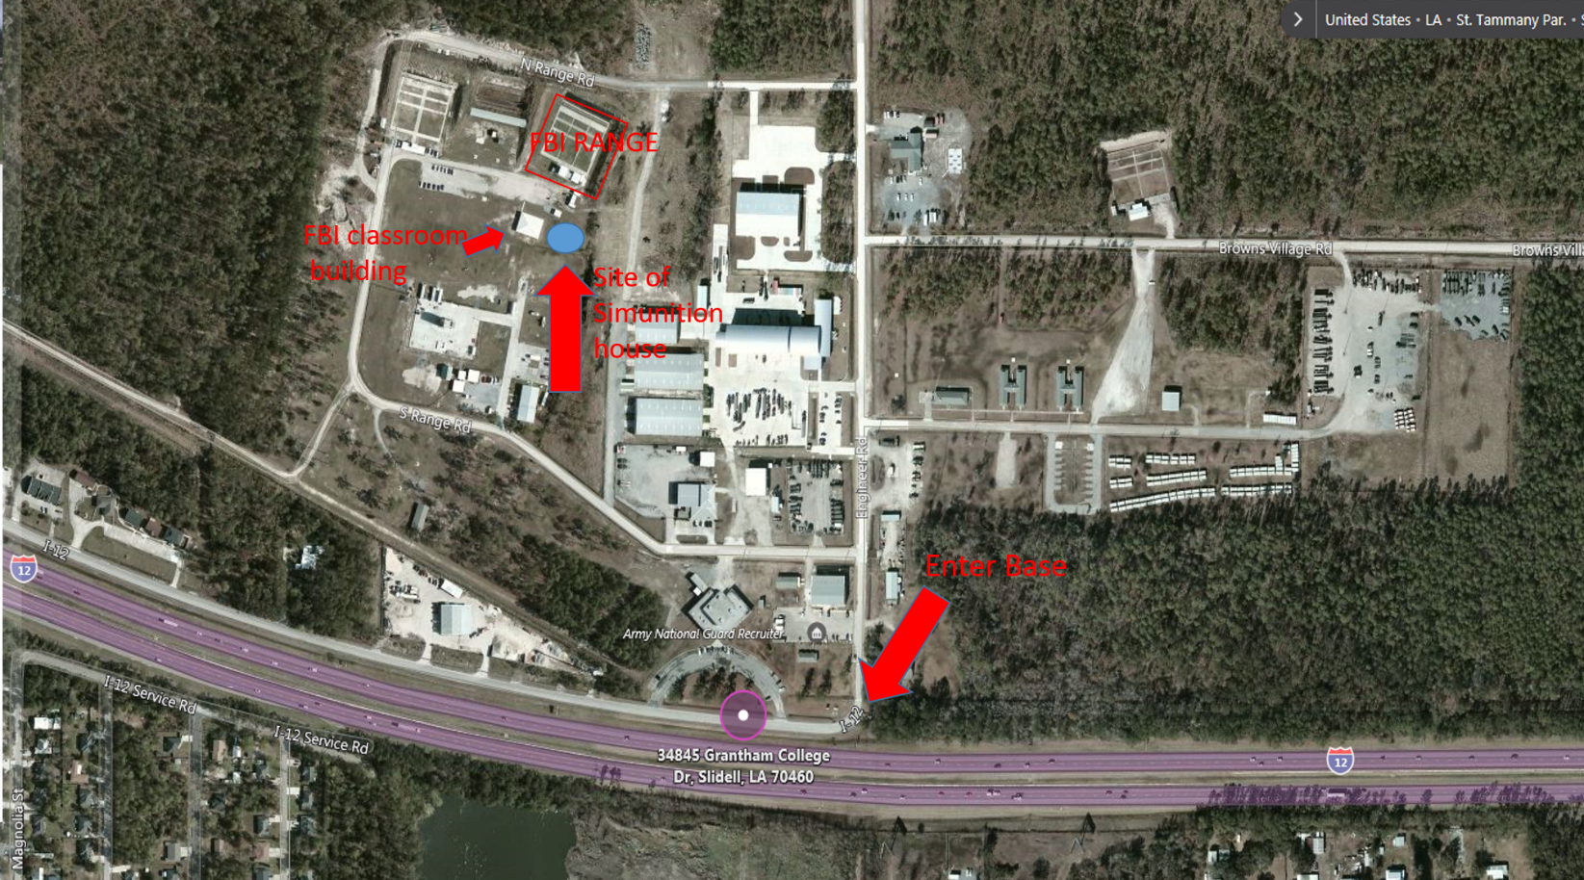

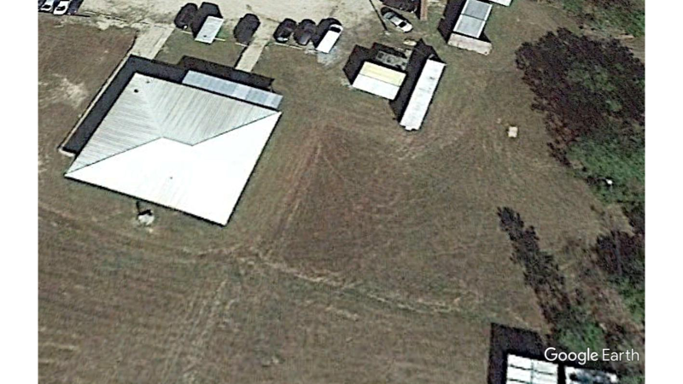
APPENDIX B
FBI, New Orleans, LA
Sample photos for moveable walls

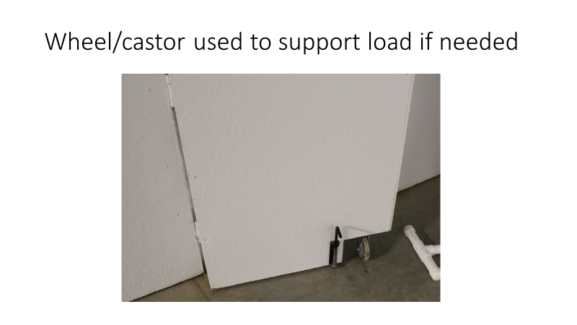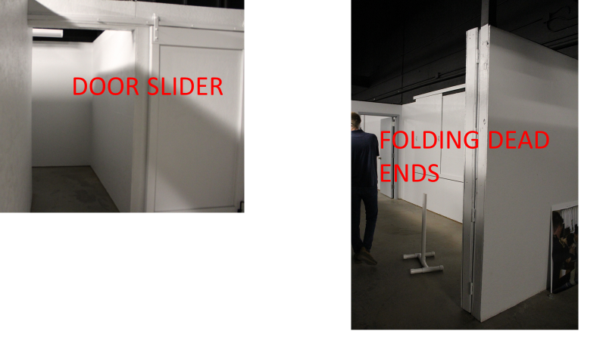

APPENDIX B (continued)
FBI, New Orleans, LA
Sample photos for moveable walls

Concept construction of wall panels and layout.

Panels should be made of one sheet of plywood with a 2X4 frame for each sheet. Additional panels sizes will be used to conform to the wall layout. These panels are then bolted together to make the walls. These walls can be taken apart and reconfigured to build other building lay outs in the future. A top 2X4 plate can be used to stabilize the walls with screw attachments to be taken apart later. The bottom of the panels should be pinned to the floor with a rod or bolt that can be removed. Interior doors are standard hollow core attached with screws to allow for easy removal and replacement. Knob should be non-locking.

Plywood can be used to make dead ends in hallways by sliders and or folding walls with a wheel to carry the load if needed. (see above photos). These should be used at the intersection of hallways and in the middle of hallways.

Sizes do not have to be the same however the layout should provide a narrow and wide hall. It should provide many doors to be used to provide maximum flexibility for the instructor running the training.

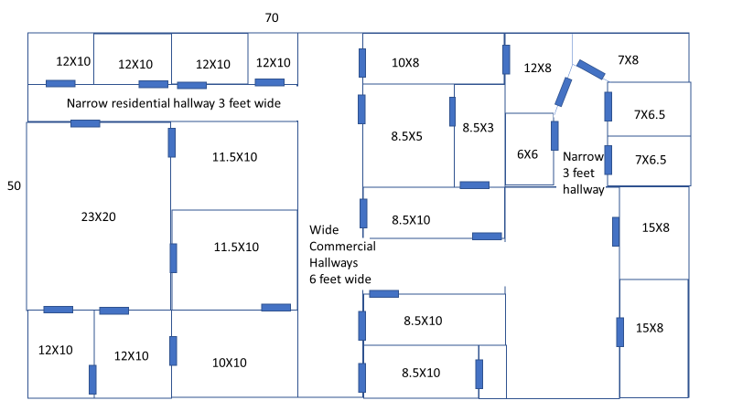

APPENDIX C (continued)
FBI, New Orleans, LA
Sample photos for moveable walls

Options for building:
Building 1
50 X 100 Sim house

Building 2
50 X 100 Sim house with Defensive Tactic (DT) room
Sim house will be 50 X 70 with 50 X 30 room. DT room with 9-foot ceiling, insulated, sheet rock, and A/C ductless system appropriately sized. This room will contain no additional walls and no windows with bare concrete floor.

Building 3
50 X 80 Sim house

